EXPERIMENT-12

AIM : . To Write a PL/SQL program for displaying the Fibonacci series up to an integer.

PROCEDURE:

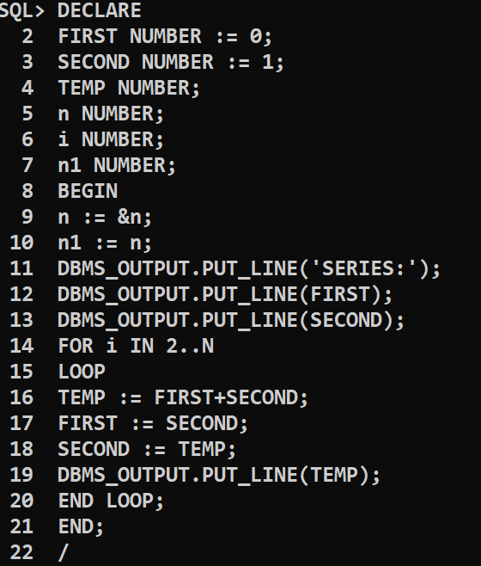

OUTPUT :

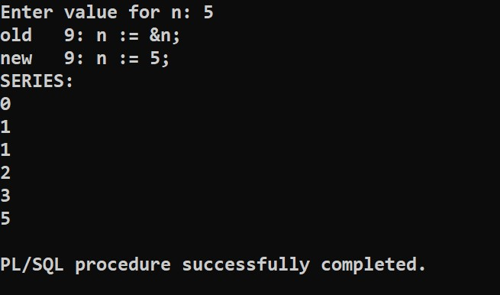

CONCLUSION : The PL/SQL program for displaying the Fibonacci series up to an integer is successfully executed.